Customer
Support Bulletin
Subject: Handling of Microchip PIC microcontroller with Sprint TLWin
Date: 6/1/2001
Author: SK

Microchip PICs:
Configuration Word/IDs are not loaded correctly by Sprint TLWin

Problem: Configuration Word/IDs are not loaded correctly by Sprint TLWin.
Different Checksums can be observed between Sprint Windows and Sprint TLWin.

Description: The file load procedure of Sprint analyzes the Microchip file and saves the data in Sprints internal file format.
TLWin, however, loads the file 1:1, and pass the data to the Sprint programming-SW bypassing Sprints file load procedure.
As a result, the 4 ID locations and the Configuration Word do not contain the proper data. Consequently, the checksum is also different.

WORKAROUND: Making the proper settings by "Programmer Properties" → "Special Features" will set the values at the ID and Configuration Word locations correctly, and will result in the correct checksum.

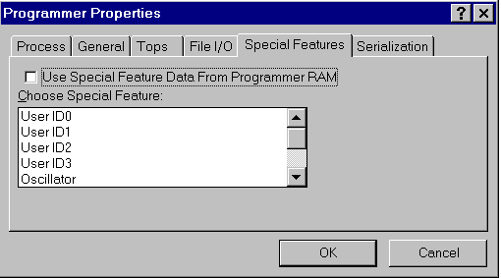

Select EACH special feature available for the selected PIC microcontroller, and set the desired value.
Make sure, that the box "Use Special Feature Data From Programmer RAM" is DISABLED ("not checked"). Then TLWin will send all special feature data defined in this dialog to the programmer.

