

DATA I/O Corporation

10525 Willows Road NE
Redmond, WA 98052
Phone: 1.425.881.6444
Phone: 1.800.247.5700 (press 2)
FAX: 425.867.6972
FSE@dataio.com

Subject: AH400 Service Release 3.9.11 Install Procedure

Model Affected: PP100, PS200 and PS300

- PURPOSE: To inform customers how to install the service release 3.9.11

2.0 TOOLS REQUIRED: NONE

3.0 SOFTWARE REQUIRED: AH400_3911.ZIP

- INSTRUCTIONS:
  - Create a backup folder of C:\AH400_32. This is on the
Handler computer.
  - Unzip the file AH400_3911.zip into a temporary folder.
  - Rename the file WINAH400.ini to WINAH400BU.ini.
  - Copy the files AH400_3911.exe, WINAH400.ini and AH400_Msgs.dll to C:\AH400_32 on the Handler computer.
  - Copy the file PackageTemplate.txt to C:\AH400_32\Package. This is on the handler computer.

  - Next from Windows Explorer make C:\AH400_32 the current directory.
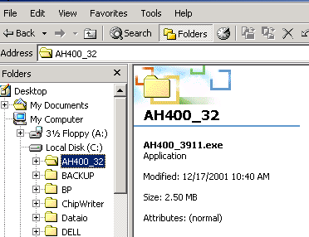

  - Register the AH400_Msgs.dll by going to the Start button, then to Run.
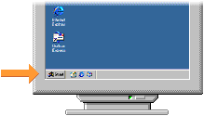

  - Type Regsvr32 “AH400_Msgs.dll”

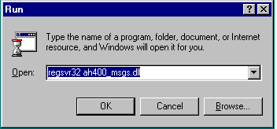

  - Then the message DLL Register Server in AH400 msgs.dll succeeded will appear. Press OK.
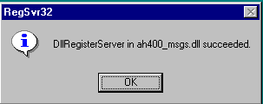

  - Then you will need to edit the file WINAH400.ini to match your
system configuration. Example: How many programmers, Laser installed, Tube feeder installed. Etc.
  - Next change your desktop target to C:\AH400_32\AH400_3911.exe. Then rename your icon to AH400 3.9.11.
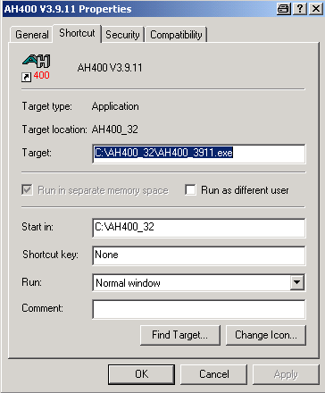

BUG FIXES
- Z-Automatic feature sometimes caused nozzle to oscillate and never complete or complete with wrong value.

- Gantry window: When a position was clicked beyond the work envelope borders, where the gantry could not move, the text boxes would contain those new coordinates. In the worst case that could cause a run-time error 11 "Division by zero".

- The automatic uploading of Winmark files or label files sometimes never happened due to timing issues.

- Found memory leak.

- Sometimes and for no obvious reason the message "Time Out at Shuttle System" would appear. This happened especially when a door was open for a long time.

- Machines with manual vibrators: After closing the door and clicking OK vibrator 1 would start vibrating even in the Gantry window. That depends now on whether the machine was actually processing devices when the door was opened.

- Tray/Tube Stop feature debugged.

- Sometimes the calculated Finish Date was earlier than the start time of the job itself.

- Collision zone computation debugged. The zone is used in AH400 mode B (obsolete configuration).

- Programmer Retry feature debugged.

- One input/pass tray: After the first 6 vacuum errors at the beginning of a new lot a message came up "Need free space on input/pass tray", although no device was in programmer yet.

- Only empty job report files were available for logic devices (SPRINT PAL software).

- Message "Main Air off" sometimes was displayed without reason. A software filter was implemented.

- The Reject Tray can be taught with or without a chip now.

- The switch "Use Marking" now is preset according to the job, not according to the last usage. This is to enforce separate jobs for marking and not marking.

- Only active options are visible in work envelope picture (Running window). This improves throughput.

